March 13, 2026
Md. Hasib
BSc. IN sTATISTICS, UNIVERSITY OF cHITTAGONG
Retail Sales Analysis Report
Prepared for: Mr. Smith

Table of Contents
1. Executive Summary 2
2. Introduction 2
2.1. Project Objective 2
2.2. Dataset Overview 2
3. Methodology 3
4. Key Findings & Insights 3
4.1. Data Quality 3
4.2. Customer Demographics 3
4.3. Product Performance 3
4.4. Spending Patterns 4
4.5. Temporal Sales Trends 5
5. Interactive Dashboard 6
6. Conclusions & Recommendations 7
7. Appendix 8

1. Executive Summary
This report presents a comprehensive analysis of retail sales data to uncover key patterns in customer behavior, product performance, and sales trends. The primary goal was to derive actionable insights that can inform marketing strategies, inventory management, and business growth initiatives.
The analysis was conducted using Python for in-depth exploration and Power BI for interactive dashboard visualization. Key findings reveal that the core customer segment is adults aged 18-50, with a nearly even split between male and female customers. While Clothing is the most frequently purchased category, Electronics generates the highest overall revenue. Sales exhibit clear temporal patterns, peaking on Saturdays and in the month of May.
Based on these findings, key recommendations include focusing marketing efforts on the 18-50 age group, designing targeted weekend and seasonal promotions, and developing category-specific strategies to maximize both revenue (Electronics) and customer engagement (Clothing).

2. Introduction

2.1. Project Objective
The objective of this project was to analyze a retail sales dataset to understand sales patterns, customer behavior, and product performance. The insights gained are intended to support data-driven decision-making.

2.2. Dataset Overview
The analysis is based on transaction-level data containing the following fields:
- Transaction ID
- Date
- Customer ID
- Gender
- Age
- Product Category
- Quantity
- Price per Unit
- Total Amount

3. Methodology
The analysis followed a structured process:
- Data Inspection: The dataset was initially examined for quality issues, including missing values, duplicates, data type correctness, and outliers.
- Data Cleaning: Minimal cleaning was required. The primary transformation was converting the Date column from a text object to a datetime format to enable time-series analysis.
- Exploratory Data Analysis (EDA): Using Python (Pandas, Matplotlib, Seaborn) in a Jupyter Notebook, we analyzed:
  - Customer demographics (age, gender).
  - Purchase behavior (spending, quantity).
  - Product category performance.
  - Sales trends over time (daily, monthly).
- Dashboard Creation: An interactive dashboard was built in Power BI to visualize the key findings and allow stakeholders to explore the data dynamically.

4. Key Findings & Insights
This section details the primary discoveries from the analysis.

4.1. Data Quality
The dataset was found to be clean and reliable. No missing values or duplicate records were detected. No significant outliers were identified that would skew the analysis. The only necessary adjustment was the date format conversion.

4.2. Customer Demographics
- Age: The most active customer base is concentrated in the 18-50 age range, with a notable peak in transaction frequency around the ages of 42-44.
- Gender: The customer base is almost perfectly balanced, with 510 female and 490 male customers in the transaction data.

4.3. Product Performance
- By Frequency: Clothing is the most frequently purchased product category, indicating high customer traffic in this area.
- By Revenue: Electronics is the top revenue generator, suggesting it is the highest-value category per transaction or has a higher price point.
- Gender & Product Trends:
  - Female customers show a higher purchase frequency for Beauty products.
  - Male customers slightly dominate purchases in Clothing and Electronics.

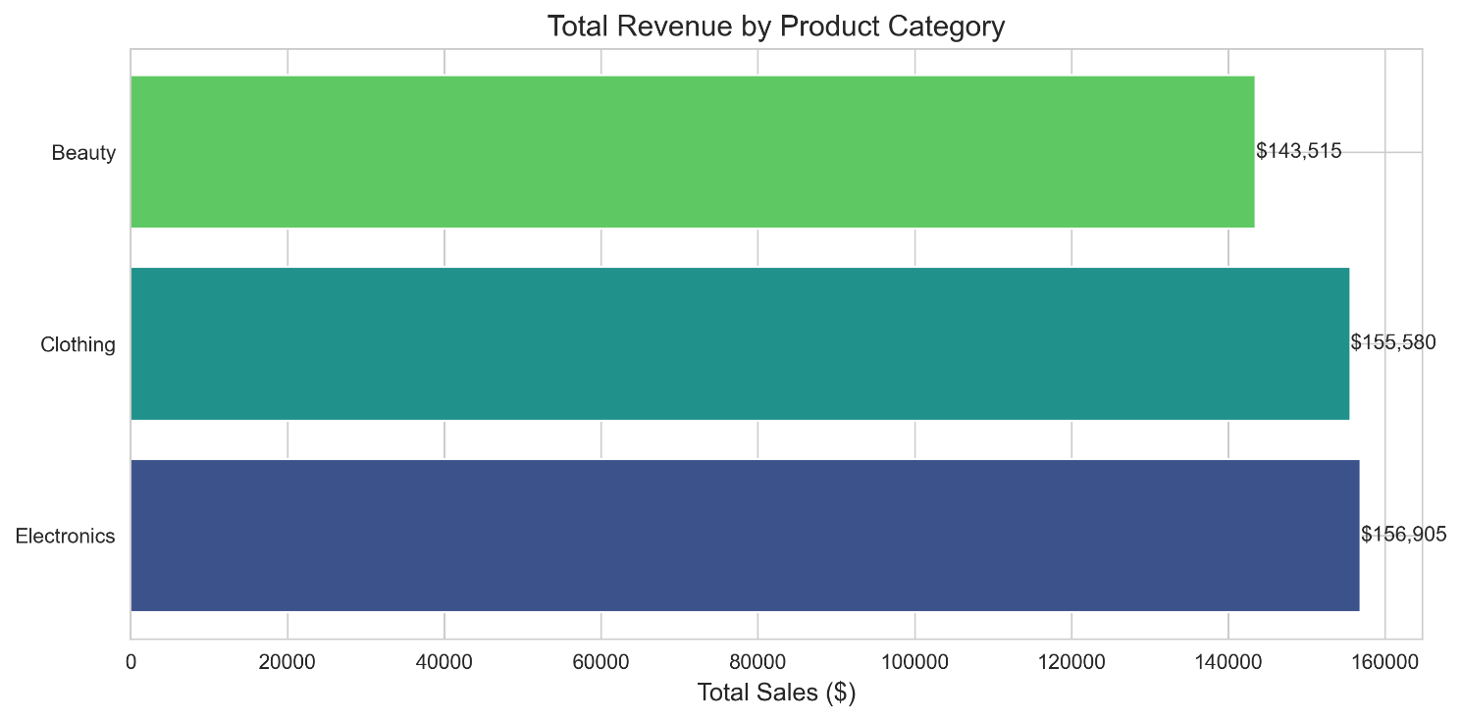
Figure 1: Sales Frequency and Revenue by Product Category

4.4. Spending Patterns
- Transaction Value: The majority of transactions are under $250. Very few transactions exceed $2000.
- Average Spending by Gender: Average spending per transaction is nearly identical for male and female customers ($456 vs. $455).
- Average Spending by Age Group:
  - Customers under 18 have the highest average spend ($534), but this group represents a very small sample size and may not be a reliable target.
  - The 18-50 age group is the most consistent and reliable spender.
  - Customers aged 60+ have the lowest average spending ($357).

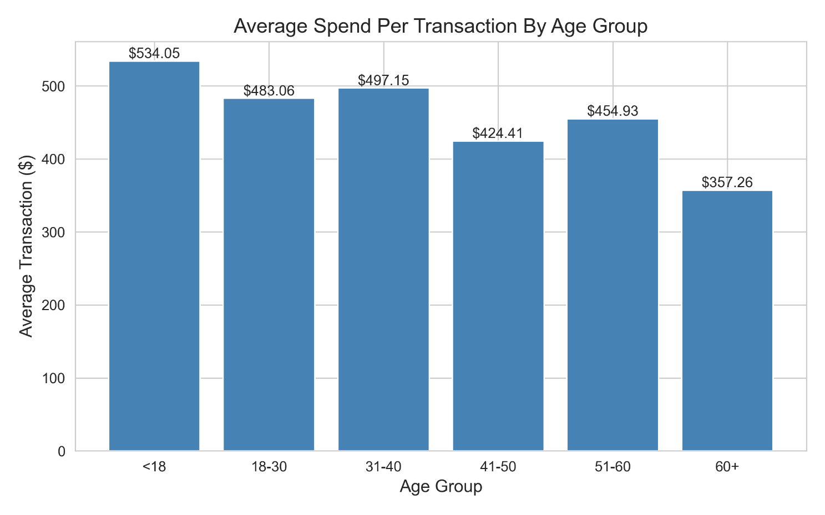
Figure 2: Average Transaction Amount by Age Group

4.5. Temporal Sales Trends
- Monthly Peak: Revenue peaks significantly in May ($53,150) , indicating a potential seasonal event or successful promotion during that period.
- Weekly Peak: Sales are highest on Saturdays ($78,815) , confirming that weekends are the prime time for customer purchases.
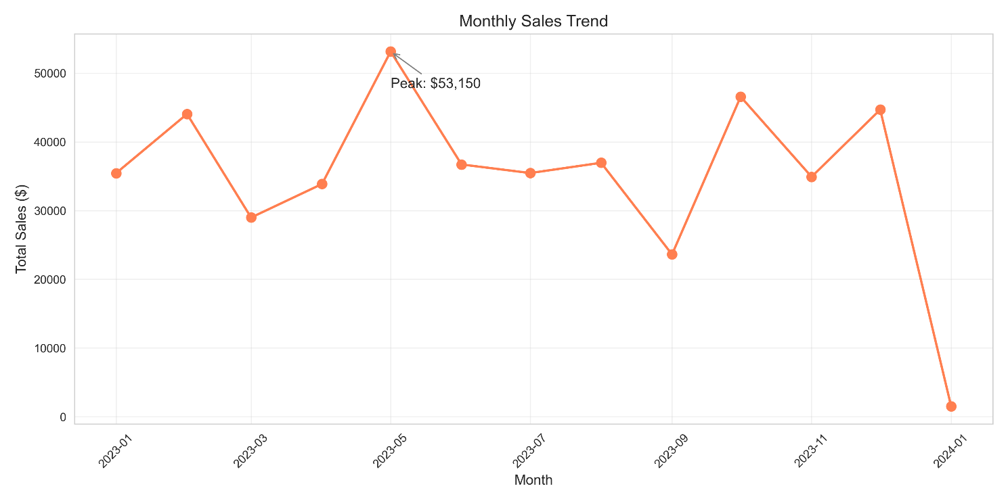
Figure 3: Total Revenue by Month

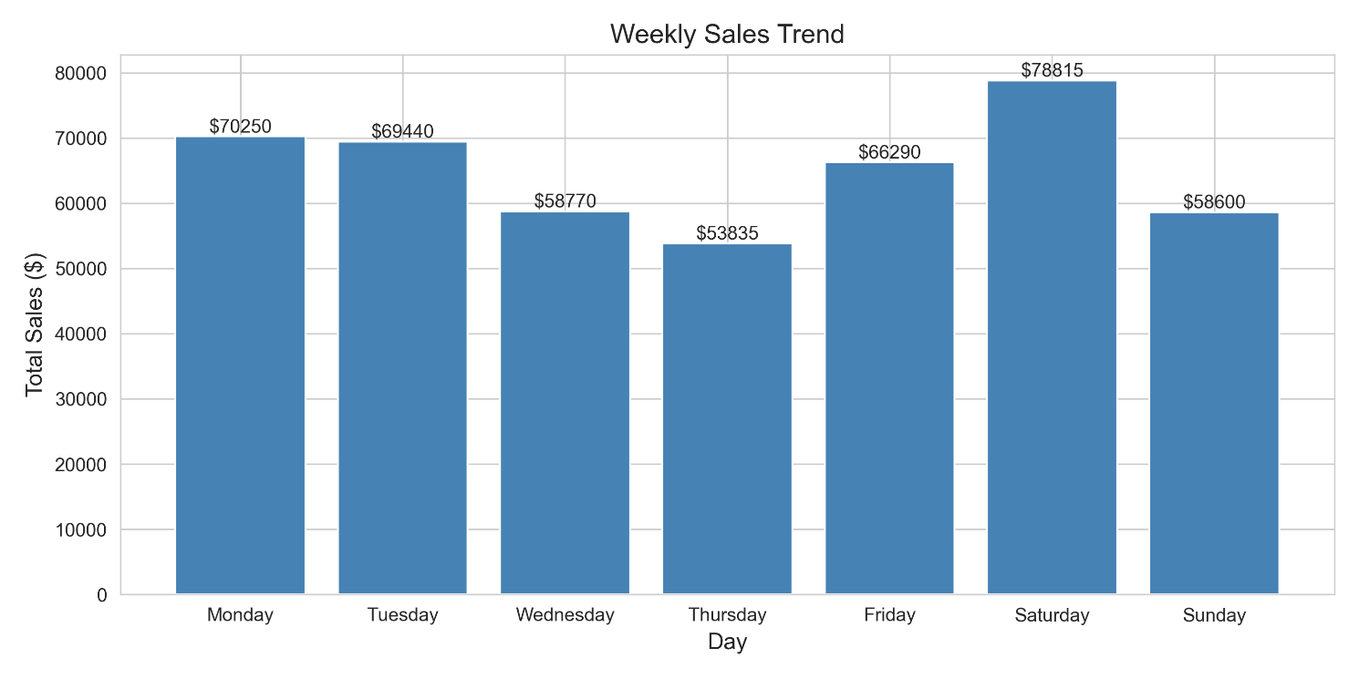
Figure 4: Total Revenue by Day of the Week

5. Interactive Dashboard
To complement this report, an interactive Power BI dashboard has been created. It allows for dynamic filtering and exploration of the data across the dimensions discussed above.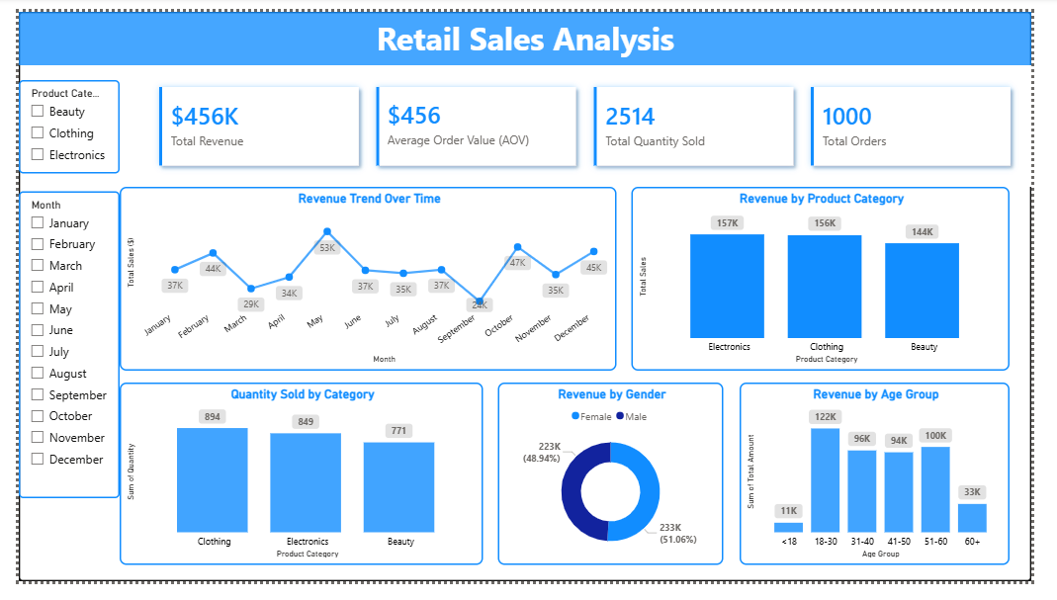
Figure 5: Interactive Retail Sales Dashboard (Screenshot)
You can access the live or interactive version here: https://github.com/mdhasibstats/retail-data-analysis/tree/8be529b8ad57adc87f8c5a95658e9f8f277f0606/dashboard

6. Conclusions & Recommendations
Based on the analysis, the following recommendations are made:
- Target Core Demographic: Focus marketing and loyalty efforts on the 18-50 age group, as they represent the most active and reliable customer segment.
- Optimize for Peak Times: Plan major marketing campaigns, new product launches, or special promotions for weekends (especially Saturdays) and the month of May to capitalize on peak customer activity.
- Develop Category-Specific Strategies:
  - For Electronics, consider bundling, upselling, or offering premium financing options to maximize revenue from this high-value category.
  - For Clothing, use it as a traffic driver with frequent promotions, new arrivals, and cross-selling opportunities to move customers into higher-margin categories.
  - For Beauty, tailor marketing visuals and product recommendations to appeal to the predominant female customer base in this category.
- Investigate Under-18 Segment: Conduct further analysis to understand the small but high-spending under-18 segment. This could be driven by a specific product or parents purchasing for children, which would require a different marketing approach.

7. Appendix
- A. Jupyter Notebook: The full Python code for the analysis is available in the project repository: “View the full Jupyter Notebook here”
- B. Data Dictionary: A detailed description of all data fields.
- C. Tools Used:
  - Python (Pandas, Matplotlib, Seaborn)
  - Jupyter Notebook
  - Power BI
  - Git/GitHub for version control.

